PENINSULA CHAMPIONSHIP/TRIAL INFORMATION

MEMO TO: | 10 – 19yrs District Secretaries  (Please forward to Schools, Sport Co-ordinators, District Coaches, Convenors and Managers)
FROM: | REGIONAL CONVENOR – Callum Troyahn supported by Peninsula School Sport
RE: | 2025 PENINSULA SCHOOL SPORT 10-19 Years Cross Country  REGIONAL CHAMPIONSHIPS

DATE: | Tuesday 13th May 2025
START TIME: | Course orientation from 8:00am – Traffic control will be onsite from 8:30am
FINISH TIME: | 2:40pm
VENUE & VENUE ADDRESS: | Avenue of Honour and Tinaburra Reserve  Tinaburra Drive  Please note, as the event is being held within the vicinity of the Avenue of Honour, please communicate with team officials, students and families of the importance it holds for the community and the utmost respect it must be given please ensure all signs and directions around the area must be adhered to  Please be mindful of driving on the road as competitors are racing along it and cross at checkpoint 4 which is managed by Yungaburra Police
TEAM SIZE: | Each district may enter up to 8 competitors per age group per gender. Ensure team paperwork is handed to Peninsula officials in the morning.  TCC, TCS, TCN, Cassowary Coast and Tablelands are required to provide 2 course marshals and at least 1 team manager Central Cape and Torres Strait are required to provide at least 1 course marshal and at least 1 team manager  Up to 6 (+2 shadows) will be selected from each age group and gender to attend the State Championship.  Multi-Class athletes: All Multiclass students are invited to compete please note the following:  - 10-12s Boys and Girls Multi-Class run 2km  13-19s Boys and Girls Multi-Class run 3km  - Classification must be listed in district nominations if known and if athlete is not on AA Masterlist please ensure classification process is underway – Contact Peninsula Sport for assistance if required. If an athlete is not classified by QRSS Championships they may be unable to compete  - Multi-Class information is attached to guide in this
PROGRAM OF EVENTS: | 8:15am District Officials Meeting  8:00-8:30am Course Orientation  2:40 – Final race finished, day ends, districts depart
  Call room | Race | Individual Events
  8:45 | 9.00 a.m. | 18/19 Girls  18/19 Boys | 6km  8km
  9:30 | 10.00 a.m. | 16-17 Boys | 6km
  10:00 | 10:30 a.m | 16 -17 Girls | 4km
  10:30 | 10:55 a.m. | 10 Boys + 10-12s Multi-Class | 2km
  10:55 | 11:15 a.m. | 10 Girls | 2km
  11:15 | 11:35 a.m. | 13 Boys + 13-19s Multi-Class | 3km
  11:25 | 11:55 a.m. | 13 Girls | 3km
  11:40 | 12:15 p.m. | 11 Boys | 3km
  12:00 | 12:35 p.m. | 11 Girls | 3km
  12:30 | 12:55 p.m. | 12 Boys | 3km
  12:45 | 1:15 p.m. | 12 Girls | 3km
  1:20 | 1:40 p.m. | 14 Boys and Girls | 4km
  1:45 | 2:05 p.m. | 15 Boys and Girls | 4km
FOOD: | Students are to provide their own food and water bottles as there will be limited vendors
STATE CHAMPIONSHIP DETAILS: | Friday 18th July – Sunday 20th July 2025  St Paul’s School, Bald Hills, Met North.  Peninsula Team will be announced via email after the Peninsula trials through the districts and schools. Top 10 competitors will be asked to complete a QR code on the day so information can be forwarded once the team is selected.
ENQUIRIES: | Callum Troyahn  cgtro0@eq.edu.au

MANDATORY STUDENT BOOKLET:
All students who attend these trials are required to present the following mandatory paperwork -
(NOTE: Students who do not have this paperwork with them (which must be signed by their Parent/Caregiver & Principal) may be sent back to school and WILL NOT be allowed to participate)
- Peninsula Permission and Details Booklet – this booklet contains all forms including project consent and mouthguard form | Available in a fillable PDF  Please ensure once filled out on the computer that it is printed off and get your Principal signature
*The Student Booklet can be accessed on the Pensport website - www.peninsulaschoolsport.eq.edu.au

DISTRICT TEAM NOMINATIONS:
Each district may enter up to 8 competitors per age group per gender to participate in these championships/trials. Participants should wear District uniforms/colours or school singlet/shirt.
District Officials and Regional Team Officials are responsible for the care and supervision of students during the regional Championships/trials.
Participating Districts MUST email the following information to the Convenor by the date stated below:
Team List –  Complete all details on the attached team nomination list (provided Excel spreadsheet) and email to Callum Troyahn at cgtro0@eq.edu.au Incomplete team lists will be returned. These team lists will be used for student registration on the day of the championship / trial | Due Date:  Tuesday 6th May 2025
*All District Team lists are to be sent in by the Convenor along with the Regional Championship Report at the conclusion of the championship.

FOR THIS REGIONAL SCHOOL SPORT EVENT:

- District team managers are reminded that they are to collect their district student paperwork and provide it to the student to hand to the Peninsula managers upon selection. All student remaining paperwork should be handed to the main tent prior to departure for archiving.
- There will be a formal presentation and medallions will be presented to students within 30mins of the completion of the race.
- Selected students in the Peninsula Cross Country team will be notified by via email after the Peninsula trials through the districts and schools. No paperwork issued on the day
- There will be no try on gear for students selected in the Peninsula Cross Country Team for this event – a sizing chart can be found on the online shop for parents to access and a try on afternoon within the first week will be available to selected students.
- After students complete their race, the top 10 competitors will be asked to register their details via a QR code and selected students will be notified of their selection by the end of the week (at the latest)
- Attached is a course map – around the Avenue of Honour Precinct there is no parking available
- Please remind all students, parents/carers and officials that the Afghanistan Avenue of Honour is a memorial and to respect it as such. Attached are photos outlining where you cannot set up Marquees/Tents
- Traffic – Park in the designated areas, there is bunting and roping marking the course, Yungaburra police will control traffic along the road but please be aware at all times of athletes running on the side and crossing at checkpoint 4.
- Reminder – No team will be announced on the day, results will be finalised and Peninsula Team emailed to districts/schools.

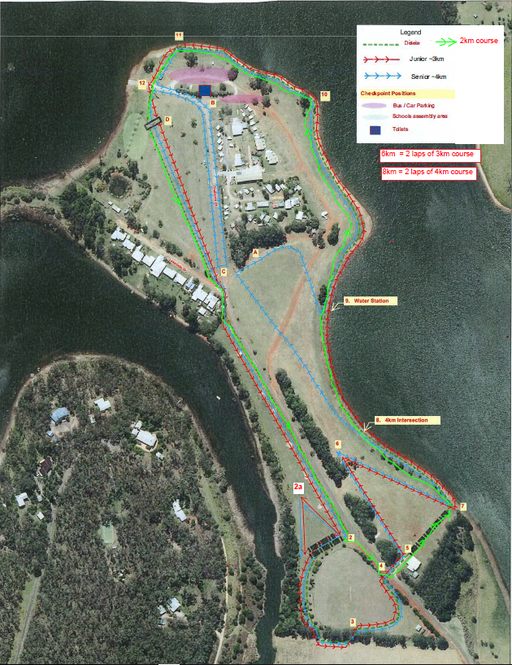
Avenue of Honour
NO PARKING AROUND IT
STARTT
FINISH

